Case Study Three Days of Canadian Winter Section 14.3 pg. 550-552
Instructions:
In this activity we will be reading weather maps and using our new knowledge to interpret weather conditions as well as predict future weather patterns. This is a useful skill as many news stations and weather reports use these maps, and the ability to read them will increase our understanding of weather forecasting.
However, meteorologists often use more detailed and complex weather maps then news outlets; these maps use more symbols to deliver more information about observed weather conditions. By gaining a higher understanding of weather maps and weather symbols, we may become even better at predicting the weather that the “weatherman”.
See page 550 and 551 in your text for the coloured maps and answer the following questions. To give yourself a better sense of realism do it one day at a time and ignore the next day’s map until you have completed all the questions.
Use the rest of this page to jot down any new facts or symbols you learn during this exercise.

Day 1: Friday, 19:00 h EST

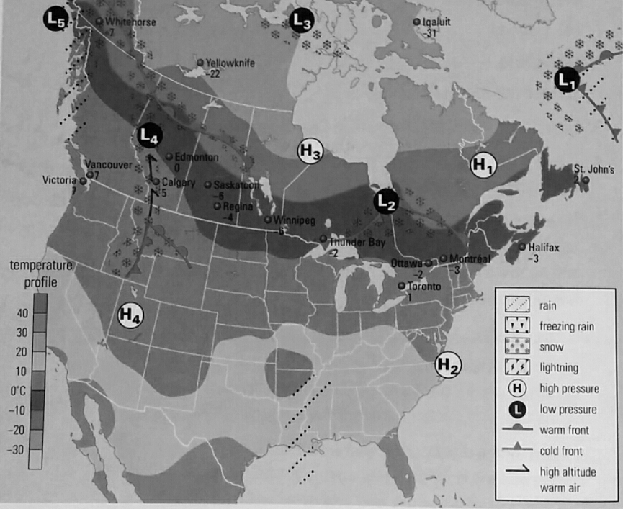
Figure 1

This map of current conditions on Friday shows the location of the various fronts and high- and low-pressure systems near the ground. To make tracking easier, each system has been numbered.

Day 1: Friday, 19:00 h EST
(a) Which pressure system in the map in Figure 1 has the greatest amount of precipitation? The least? Explain how you made your decision. _________________________________________________________________________________________________________________________________________________________________________________________________________________________________________________________________________________________________________________________________________________________________________________________________________________________________________

(b) In cyclogenesis, cold fronts tend to rotate faster than warm fronts, thus catching up to the warm fronts and causing even more precipitation. Which weather system illustrates this principle?
_________________________________________________________________________________________________________________________________________________________________________________________________________________________________________________________________________________________________________________________________________________________________________________________________________________________________________

(c) Create a 24-h weather forecast for your area based only on this map. _________________________________________________________________________________________________________________________________________________________________________________________________________________________________________________________________________________________________________________________________________________________________________________________________________________________________________

Day 2: Saturday, 19:00 h EST
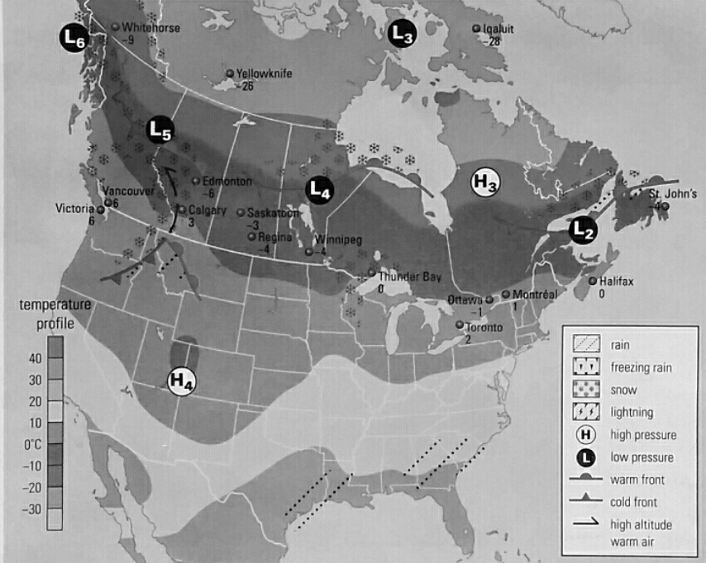
Figure 2

Day 2: Saturday, 19:00 h EST

(d) In what general direction are the pressure systems in Southern Canada moving? __________________________________________________________________________________________________________________________________________________________________________

(e) Do the pressure systems in the Arctic appear to be moving at the same speed as the systems in southern Canada? Explain your answer. _________________________________________________________________________________________________________________________________________________________________________________________________________________________________________________________________________________________________________________________________________________________________________________________________________________________________________

(f) Calculate the average speed of a mid-latitude pressure system over the past 24 hours. (To help determine the distance travelled, assume that the distance from Victoria to St. John’s is 4700 km.)

(g) Create a 24-h weather forecast for your area based on the maps in Figure 1 and 2. ____________________________________________________________________________________________________________________________________________________________________________________________________________________________________________________________________________________________________________________________________________________
Day 3: Sunday, 19:00 h EST

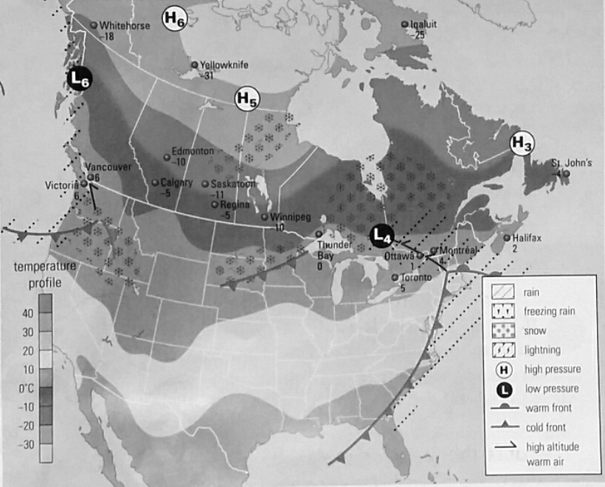
Figure 3

Day 3: Sunday, 19:00 h EST
(h) In the past 24 h, which region of Canada has had the greatest amount of precipitation? The most stable, pleasant weather? Explain your answers. _________________________________________________________________________________________________________________________________________________________________________________________________________________________________________________________________________________________________________________________________________________________________________________________________________________________________________

(i) In which area(s) of this map can you see cyclogenesis? _______________________________________________________________________________________________________________________________________________________________________________________________________________________________________________________________

(j) Can you find any examples of precipitation being caused by moving air masses without cyclogenesis? If so, where? _____________________________________________________________________________________

(k) Create a 24-h forecast for Monday for your area based on Figures 1, 2, and 3. _________________________________________________________________________________________________________________________________________________________________________________________________________________________________________________________________________________________________________________________________________________________________________________________________________________________________________

(l) On a Map of Canada, draw what you think will be the weather map for all of Canada on Monday at 19:00 h, Day 4 of the sequence.

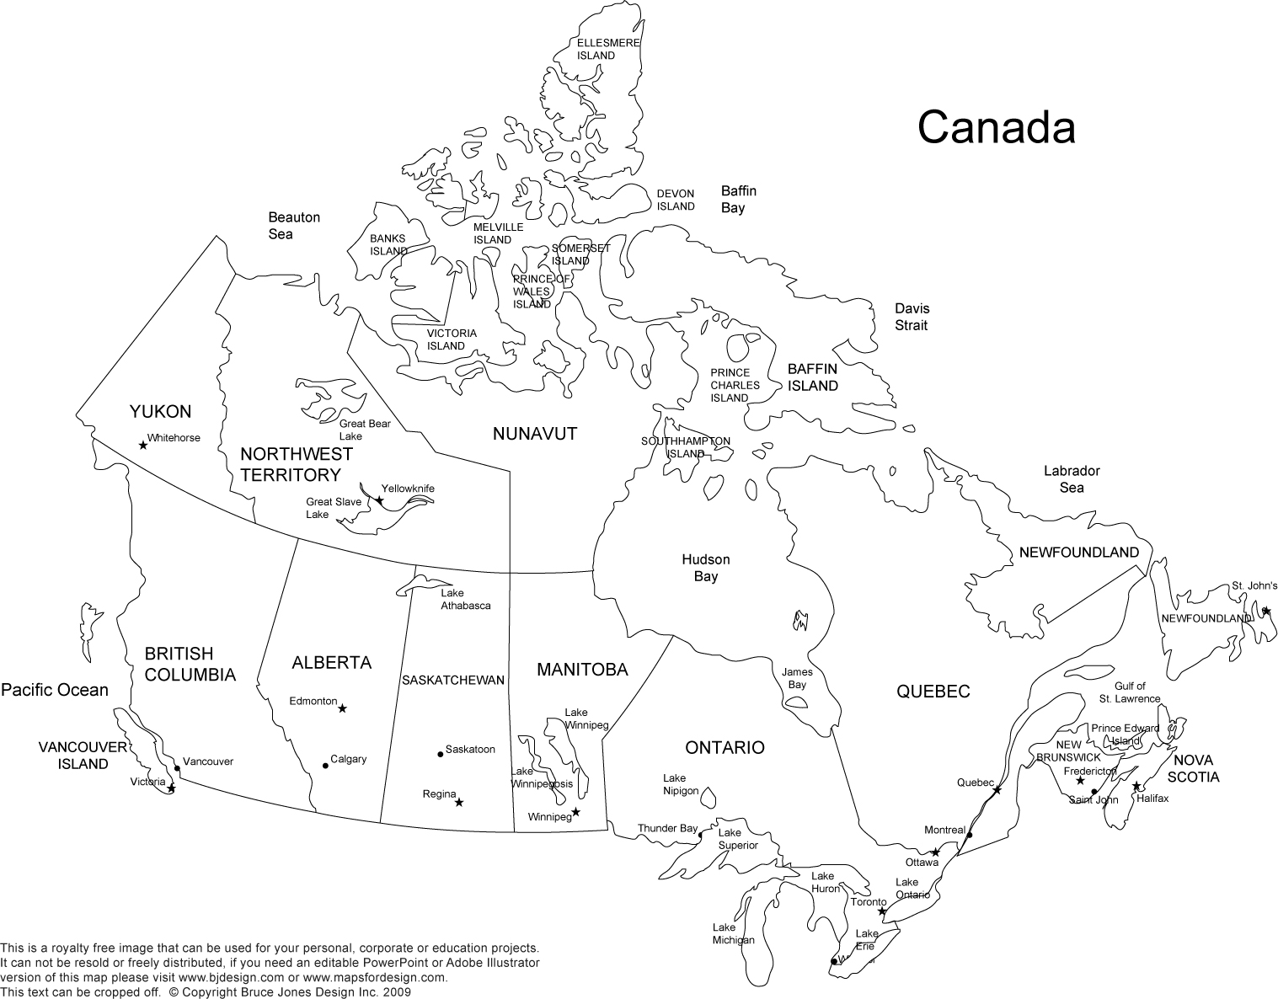

Further interest: Take this new knowledge and go to www.theweathernetwork.com, Environment Canada or any other weather tracking news website and find a radar or satellite image of Newfoundland. Do you recognise anything from this Case Study? Can you predict the weather for tomorrow?
Zoom out and look at all of Canada, North America, or even the whole world. DO you see any familiar weather systems? If so, which ones. Did you learn anything from this activity?

