Unit II - Bio 2201 Name ________________________________________

Dichotomous Key Activity
http://prezi.com/zjessvgtwobc/dichotomous-keys/

What are dichotomous keys?

There are many different kinds of dichotomous keys and some are easier to use than others. A dichotomous key is a tool that allows the user to determine the identity of items in the natural world, such as trees, wildflowers, mammals, reptiles, rocks, fish, etc. They consist of a series of paired statements termed couplets that describe some feature of any given biotic (living) or abiotic (non-living) thing. "Dichotomous" means "divided into two parts". Therefore, keys consist of a series of “either or” choices between alternative characteristics that progressively lead the user to the correct identification of the organism/object. The statements, or couplets, are in direct contrast with each other (i.e., mutually exclusive).

Using a dichotomous key

Pick the specimen you want to try to identify. To use the key, begin with the first couplet and select the statement that best fits is characteristics. This will direct you to another couplet and ultimately provide the identity of your specimen.

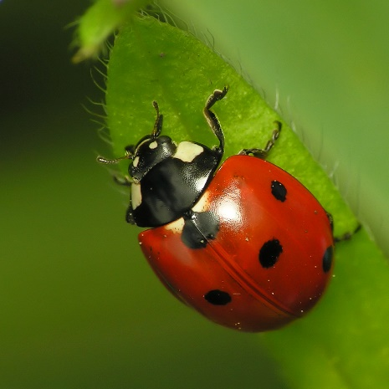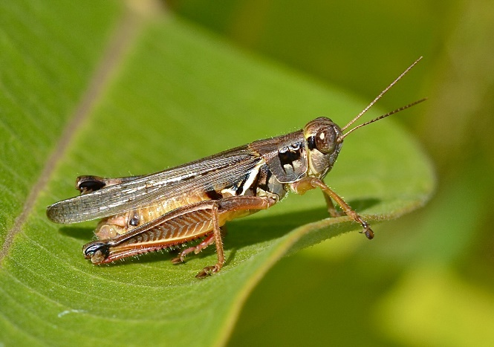

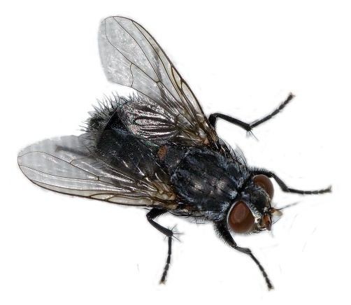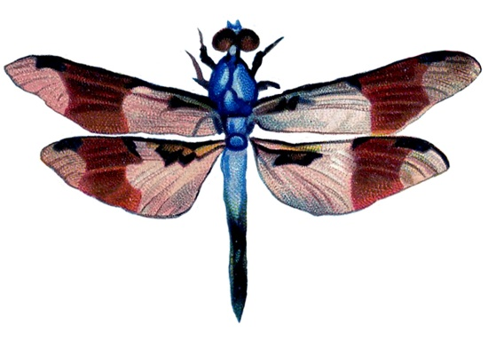

Using a dichotomous key…cont’d

1a. Wings are covered by an exoskeleton; go to 2.
1b. Wings are not covered by an exoskeleton; go to 3.

2a. Body has a round shape; LADYBUG.
2b. Body has an elongated shape; GRASSHOPPER.

3a. Wings point out from the side of the body; DRAGONFLY.
3b. Wings point to the posterior (back) of the body; HOUSEFLY.

Writing a dichotomous key

You are an expert on Martian taxonomy. You have been asked to construct a dichotomous key that anyone can use to identify these newly discovered creatures. Remember, you are classifying new species and therefore need to give them genus/species names! It is best to start with a feature that separates the characteristics to be keyed into two groups and then subdivide these groups until individuals are distinguished.

Tips for writing your key:
- make detailed observations about the specimens first
- assign a name to each representative specimen (choose a genus and species based on key feature. Be creative!)
- group specimens by common characteristics
- choose obvious visual characteristics or structures that you will use to divide the organisms into categories
- start classifying with the most distinctive or general features first; then move to specific
- use measurements rather than general description (use things like 6 legs, 3 eyes, etc.)
- the two statements within a couplet should refer to the same feature
- start couplets with the same word
- the two statements of the couplet should be mutually exclusive (i.e., they should contradict each other)
- the first couplet should not identify a specimen right away. There should be at least two characteristics that lead you to identification.

IMPORTANT: The finished key should have n-1 couplets (where n equals the number of units in the key). Eg. If you have 10 specimens, there should be 9 couplets.

1 __________________________________ 2 ___________________________________

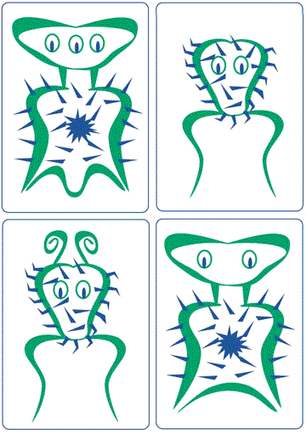

3____________________________________ 4___________________________________
5 __________________________________ 6 ___________________________________

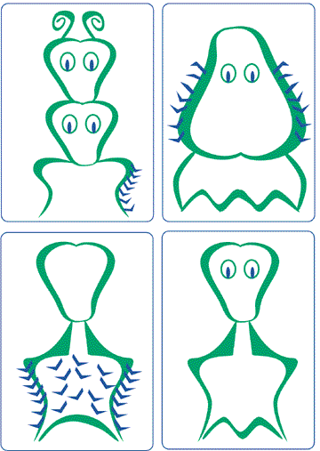

7 __________________________________ 8 ___________________________________
My Dichotomous Key

Follow up questions

- What do scientists use to classify organisms?

- Which characteristics/structures were most useful in creating your key?

- Are all dichotomous keys identical? Why or why not?

Bonus trivia:
In 2011, science estimated that 8.7 million species live on the planet. However, we have identified only a very small fraction of what is out there. Scientists believe that roughly 86% of land species and 91% of aquatic species are still unknown. This means we only know about 14-15% of land species and about 9-10% of aquatic species that exist on the planet!

It has also been suggested that ~ 40 new species of organisms are discovered every day!

Sources:
http://news.nationalgeographic.com/news/2011/08/110824-earths-species-8-7-million-biology-planet-animals-science/

http://www.sciencedaily.com/releases/2011/08/110823180459.htm

