Biology 3201: Genetics Assignment

Crosses Involving One Trait (Monohybrid)

1. In the pea plant green is dominant to yellow and tall is dominant to short. For each cross determine the phenotype and genotype.

- Cross two heterozygous green plants

b. Cross a homozygous green plant with a heterozygous green plant.

c. Cross a homozygous tall plant with a short plant.

2. In squash, the allele for white fruits (W) is dominant over the allele for yellow (w). If a white-fruited plant is crossed with a yellow-fruited plant and all of the offspring are white, what are the possible genotypes of the parents and the offspring?

Crosses Involving Two Traits

3. In mice, the ability to run normally is a dominant trait. Mice with this trait are called running mice (R). The recessive trait causes mice to run in circles only. Mice with this trait are called waltzing mice (r). Hair color is also inherited in mice. Black hair (B) is dominant over brown hair (b). For each cross show the parental genotypes and determine the genotypes and phenotypes of the offspring.

- Cross a heterozygous running, heterozygous black mouse with a homozygous running, homozygous black mouse.

b. Cross a homozygous running, brown mouse with a heterozygous running, pure black mouse.

Product Rule of Consecutive Events

4. Brown eye colour is dominant to blue eye colour. If both parents are heterozygous for brown eyes, determine the probability of each of the following:

a. Having two brown-eyed children, followed by a blue-eyed child

b. Having three brown-eyed children in a row

c. Having three blue-eyed children in a row

d. Having a blue-eyed child, followed by a brown-eyed child, followed by a blue-eyed child.

Crosses Involving Multiple Alleles and Codominance

5. A woman homozygous for type B blood marries a man who is heterozygous type A. What will be the possible genotypes and phenotypes of their children?

Crosses Involving Incomplete Dominance

6. In some cats the gene for tail length shows incomplete dominance. Cats with long tails and those with no tails are homozygous for the respective alleles. Cats with one long-tail allele and one no-tail allele have short tails. Predict the genotypic and phenotypic ratios of a cross between

a. A long-tail cat and a cat with no tail

b. A long-tail cat and a short-tail cat

c. Two short-tail cats

Test Cross

7. In peas, the allele for tall plant height (T) is dominant over the allele for short plant height (t). A tall pea plant (T_) was crossed with a short pea plant (tt). Of the 95 offspring that resulted, 55 were tall and 40 were short. Determine the genotype of the tall parent plant.

8. An Alaskan malamute can either be normal size or dwarf. A normal Alaskan malamute male breeds with a dwarf female. They have four offspring that are all tall.

a. What are the likely genotypes of the parents?

b. Why can you not be certain of the genotype of the father?

c. Determine the probability that you may be wrong.

9. Case #1: The Case of the Lost Son??
Read the story and answer the questions that follow. See if you would have made the same decision that the judge in the story made.
Mr. Cash died and left his money to his two children. A young man claiming to be his lost third son sued for his share of the estate. The judge ordered blood tests for all family members and for the young man. Mr. Cash’s blood was already on record. He had type AB blood. His wife had type A, and the young man who claimed to be his son had type O. The judge quickly dismissed the case.
Questions
- Genotype that would produce phenotype A:_____________________________.
- Genotype that would produce phenotype AB:____________________________.
- Genotype that would produce phenotype O:_____________________________.
- Using a Punnett square, diagram the offspring that could be produced if Mrs. Cash had genotype AA and Mr. Cash had genotype AB.
What could result from this mating?

- Using the Punnett square, diagram the possible offspring if Mrs. Cash had genotype AO, and Mr. Cash had genotype AB. List the phenotypes that could result from this mating. (Punnett square on next page)

- What are the possible Genotypes of a person having blood type O?

______________________________________________________________
- What is the genotype of a young man claiming to be Mr. Cash’s long lost son?
_______________________________________________________________
- Do you agree, or disagree with the judge’s decision? Explain.
______________________________________________________________
______________________________________________________________
______________________________________________________________
______________________________________________________________
10.Case # 2: A Murder Mystery
Read the following story and answer the questions that follow.
As a bolt of lightning flashed above Black Mourning Castle, a scream echoed from the den of Lord Hooke. When the upstairs maid peered through the door, a freckled arm reached for her neck. Quickly, the maid bolted from the doorway, locked herself in her room, and telephoned the police.
Inspector Hardy arrived to find a frightened maid and the dead body of Lord Hooke. The inspector quickly gathered evidence. She noted the blood on a letter opener, even though Lord Hooke had no cuts. The blood sample proved to be the type O, Rh negative. The quick thinking inspector gathered all of the members of the family and began taking blood samples. The chart below shows the relatives who were in the castle at the time of Lord Hooke’s murder.
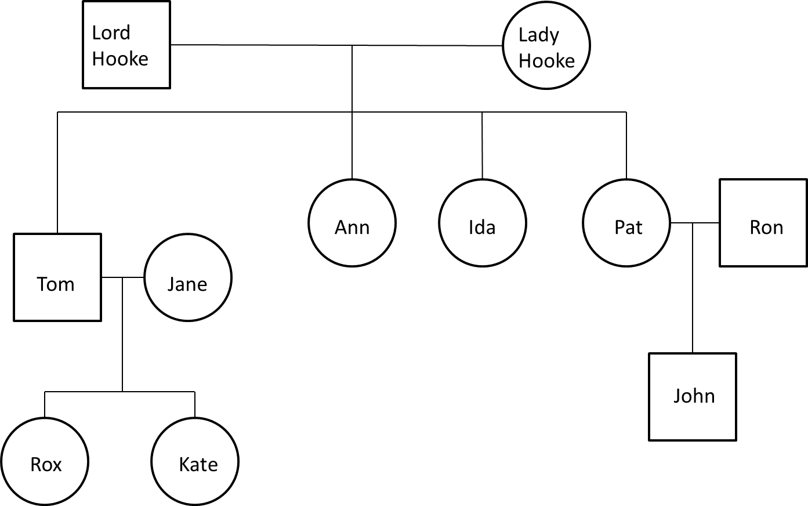
Family Member | Blood type | Rh Factor | Freckles
Lord Hooke | AB | + | No
Lady Hooke | A | + | No
Pat | A | + | No
Ron | O | + | No
John | REFUSED | REFUSED | ?
Ida | A | - | ?
Ann | B | + | ?
Tom | O | - | No
Jane | A | + | ?
Rox | O | - | ?
Kate | A | + | Yes

The inspector found it difficult to determine freckles with people who were wearing long-sleeved shirts. Note that freckles is dominant to no freckles.
At last, Inspector Hardy gathered all of the family close together and indicated that she had found the murderer. She explained that Lady Hooke had been unfaithful to her husband. One of the heirs to the fortune was not actually a sibling. The murder was committed to preserve a share of the fortune.
- Who was the murderer? State reasons for your answer.

- How did the inspector eliminate the other family members?

11. Having double eyelashes is a sex-linked trait. This trait is recessive (d) to normal eyelashes (D). A normal man marries a woman who is a carrier of the trait.

a. What percentages of the sons will have double eyelashes?

b. List the genotypes of the daughters.

12. A man with haemophilia marries a homozygous normal woman. Predict the genotypes and phenotypes of their children.

13. If a normal sighted woman whose father was colour-blind marries a colour-blind man, what is the probability that they will have a son who is colour-blind?

14. What is the probability that a colour-blind woman who marries a man with normal vision will have a colour-blind child?

