Viruses

Textbook Reference: Section 4.3

Viruses are infectious agents with both living and nonliving characteristics.

1. Living characteristics of viruses
- They reproduce at a fantastic rate, but only in living host cells.
- They can mutate.

2. Nonliving characteristics of viruses
- They are acellular, that is, they contain no cytoplasm or cellular organelles.
- They carry out no metabolism on their own and must replicate using the host cell's metabolic machinery. In other words, viruses don't grow and divide. Instead, new viral components are synthesized and assembled within the infected host cell
- They possess DNA or RNA but never both, surrounded by a protein coat called a
capsid

Viral Reproduction

The Lytic Cycle (T4 Virus)

The lytic cycle can be described as follows:
1)Attachment:
- Each virus has a specifically shaped receptor protein and can only attach to particular cells with specific receptor sites. ie. T4 with E. coli
2)Penetration or Entry
- The virus injects its nucleic acid into the bacterial cell
3)Biosynthesis or Replication:
- Host protein synthesis is stopped
- T4 uses host nucleotides to replicate its DNA and host ribosomes, enzymes and amino acids to synthesize its enzymes and proteins.
4)Maturation or Assembly:
- New virus particle are assembled
5)Lysis and Release
- Release of the viruses from the host.
- The viral enzyme lysozyme, lyses (breaks open) E. coli’s plasma membrane and cell wall.
- The E. coli cell dies.
- Burst time ranges from 20 to 40 minutes.
- Burst size ranges from 50 to 200 viruses.

Draw the life cycle of a T4 virus attacking an E. coli bacterium from page 123.

Viruses and Biotechnology

Genetic engineers can use viruses to introduce new genes into a cells and clone copies of the gene. This gene can be used to treat certain diseases. The foreign gene is spliced into the viral DNA and multiple copies of recombinant DNA is made containing this gene.

Draw Figure 4.23 from page 125 to show how recombinant DNA technology works

E. coli Life Cycle

Textbook Reference: Section 5.1, pages 134-5

The structure of E. coli consists of a cell wall, cell membrane and cytoplasm without a nucleus or organelles. E-coli reproduces through binary fission, or cell division. As the cell grows, it begins to elongate. It produces a copy of its DNA and a septum begins to form in the cell wall and eventually divides the cell into two. As the cell reaches a certain size it separates.

In the right conditions a bacterium can grow and divide in as little as 20 minutes.

Draw figure 5.4 from page 134 showing the division of E. coli through binary fission

- E. coli is the abbreviated name of the bacterium in the Family Enterobacteriaceae named Escherichia (Genus) coli (Species).
- The presence of E. coli and other kinds of bacteria within our intestines is necessary for us to develop and operate properly, and forus to remain healthy. E. coli, along with other species of bacteria, provide us with many necessary vitamins for example. The bacteria make the vitamins, and we gladly absorb them. We pretty much depend upon E.coli in our intestines for our source of Vitamin K and B-complex vitamins.
- If scientists want to clone a human gene such as the gene that produces insulin they would first separate the desired gene from its chromosome. They would remove a plasmid (part of the DNA) from the bacterial call and splice the gene into the plasmid.. They would insert the plasmid, with the recombined DNA into a bacterial cell. Each time the bacteria divides a new gene is copied. (page 135)
- Although most strains of E. coli are harmless and live in the intestines of healthy humans and animals, some strains produce a powerful toxin and can cause severe illness. This strain can sometimes be found in drinking water and have eroded from fertilizers, sewage or other forms of animal wastes.

Life Cycle of Plasmodium vivax

Textbook Reference: Section 5.2, page 146

Plasmodium vivax is the form of protist responsible for malaria in humans. It consists of two hosts: the mosquito and the human. The life cycle is as follows:

Stage 1: The Mosquito feeds on an infected person. From there it ingests reproductive cells (gametocytes) of Plasmodium present in red blood cells.
Stage 2: The reproductive cells fuse inside the Mosquito’s to form a zygote. The zygote divides many times to form numerous spore-like cell fragments. Eventually, the zygote breaks open, releasing cells called sporozoites.
Stage 3: The sporozoites invade the mosquito’s salivary gland, from where they will be injected into a new host when the mosquito bites again.
Stage 4: Inside the human host, the sporozoites reproduce asexually in the liver to form a second type of spore-like cell called merozoites.
Stage 5: From the liver, these new spores enter the bloodstream, invade red blood cells, and multiply rapidly inside them. The blood cells rupture, releasing toxic substances and great numbers of spores. These spores go on to infect more and more red blood cells. Some merozoites do not enter blood cells but become gametocytes in the bloodstream
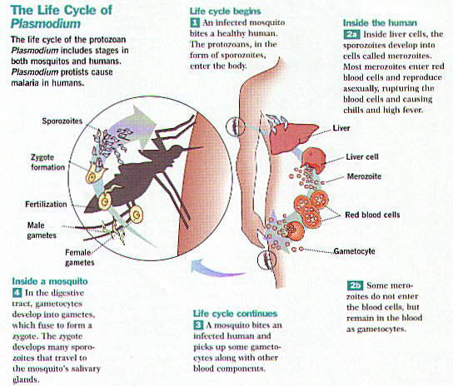

Life Cycle of Rhizopus stolonifera

Textbook Reference: Section 5.3, page 154

Fungi, like plants, grow in the ground and have cell walls. They were once considered a plant of the plant kingdom. An example of fungi is Rhizopus stolonifera, more commonly known as bread mold.

Facts about bread mold:
- Bread mold is usually found growing on substrates such as bread, cake and fruit.
- Features of its appearance include: fine, downy hair-like outgrowths on the surface that it is colonizing.
- Prefers dark, moist habitats such as storage containers, cupboards and refrigerators.

Simple structure of Rhizopus

- Many branched filaments or hyphae make up a colorless network called a mycelium. It is made up of three types of hyphae.
- Hyphae that grow on the surface of the substrate are called runners or stolons and contain the mating strains responsible for sexual reproduction
- Hyphae that penetrate the substrate surface are called rhizoids. They anchor the mold and secrete enzymes to digest food and absorb nutrients
- Sporangiophores are a form of hyphae that project up above the mycelium of a bread mould. It is used during asexual reproduction.

Life Cycle: The Rhizopus will normally undergo asexual reproduction but is capable of sexualreproduction when conditions are unfavorable.

Rhizopus life cycle: Asexual reproduction:
- Bread mold develops a third form of hyphae that project up above the mycelium
- These stalk-like hyphae, called sporangiophores, carry sporangia (spore-bearing capsules) at their ends.
- Asexual spores develop inside the sporangia, and are released when the capsules split open.

Rhizopus life cycle: Sexual reproduction.:
- During sexual reproduction zygospores are produced
- Zygospores are diploid structures the develop after two haploid hyphae of opposite types(called mating strains + and -) combine and fuse their nuclei together (diploid refers to cells that contain two copies of every chromosome.)
- A thick wall develops around the zygospore after the nuclei fuse , protecting the contents from drying and other hazards .
- When favorable conditions occur, the zygospore absorbs water and the nuclei undergo meiosis to begin asexual reproduction and form new mycelium
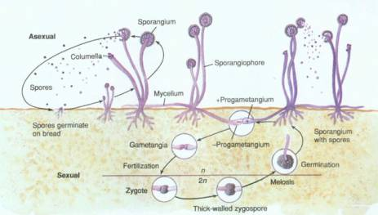

Draw the diagram on page 154 of the Rhizopus life cycle.

The Fern Life Cycle

Textbook Reference: Section6.2, page 173

Ferns and relatives are surviving members of the earliest lineage of vascular plants that originated over 450 million years ago. These plants reproduced by means of spores and did not produce flowers, fruits, or seeds. The plant we commonly recognize today as a fern is the sporophyte generation of a life cycle that includes both sporophyte and gametophyte generations. This is commonly referred to as alternation of generations.

A sporophyte produces spores as a reproductive method. The spores grow on the pinnae which are leaflets on the larger fern fronds. On the under side of the leaflets are brownish spots called sori which are made up of clusters of sporangium which are the spore producing structures. Inside the sporangium a mother spore cell, which is a diploid cell, undergoes meiosis and produces four haploid spore cells. These spore cells can further divide by mitosis to produce more spores.

As the humidity decreases the sporangium open up and release the spores. If the spores land on suitable moist growing surface they will germinate and grow from a thread like protonema into a heart shaped prothallus that is approximately 1 cm wide. The prothallus contains chloroplasts and produces its own nourishment through photosynthesis. As the prothallus grows it develops rhizoids, archegonia and antheridia. Each of these structures have the following purposes:
- rhizoids are root like structures that absorb water and nutrients from its surroundings
- archegonia are the female structures and produce eggs
- antheridia are the male structures and produce sperm cells

Both the archegonia and the antheridia produce their reproductive cells through mitosis. If the conditions are moist enough the archegonia will release its egg cell and traces of malic acid which will attract the sperm cells. The sperm cells can swim in water to the egg which is then fertilized to produce a diploid zygote. The zygote will then continue to grow mitotically. It will go through phases of being an embryo and then a small sporophyte plant that grows on the prothallus. Eventually the plant will develop roots and grow on its own to create an adult fern.

Gametophyte Generation (n)
- Spores – once sporangia mature, the haploid spores are released by movements. The sporangium will then split open at the weaker part of the wall. (n)
- Gametophyte – The haploid gametophyte is formed by mitosis from the spore , it has one cell and has a thick heart shaped structure called the prothallus
- Archegonium - Archegonia develop on the lower surface of the gametophyte, concentrated in the cleft. Each archegonium produces a single egg by mitosis.
- Antheridium – antheridia form small bulges around the lower surface of the gametophyte. Sperm are produced
- Fertilization – dependent on water. The antheridia burst open, it allows the sperm to swim to the archegonia. (2n)

Sporophyte Generation (2n)
- Zygote - moisture causes the archegonia to open. The sperm then fuses with the egg cell to form a diploid zygote
- Young Sporophyte – growth by mitosis and development of the zygote, produces the young sporophyte. The gametophyte will nourish the sporophyte until it becomes independent. When it grows it will form a mature plant that can produce spores and from that the cycle continues.
- Sporophyte – This is the typical fern plant the we normally observe
- Sporangia – the fertile fronds bear groups of sporangia on the lower surface. Haploid spores are produced in the sporangium following meiotic divisions.(n)

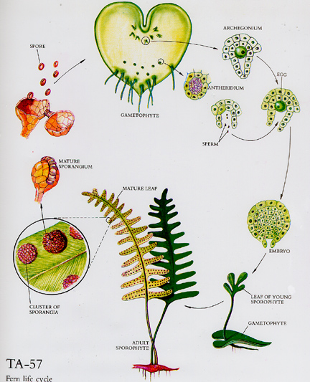
The Life Cycle of a Frog

Textbook Reference: Section 6.3, page 193

Like all amphibians, frogs spend their lives near water because they must return to the water to lay their eggs. Frog eggs are laid in the water. When they hatch into tadpoles, they breathe with gills and swim using a tail. As they mature, they lose their tail, and they develop lungs for breathing air. In harsh climates, frogs bury themselves in sand and mud and hibernate through the cold winter.

Eggs-Tiny frog eggs are laid in masses in the water by a female frog. The eggs hatch into tadpoles. Some frogs leave after this point, but others stick around to watch over the little ones as they grow.

Tadpole - (also called the polliwog) This stage hatches from the egg. The tadpole spends its time swimming in the water, eating and growing. Tadpoles breathe using gills and have a tail.
- At 2 days old, the tadpole still feeds on the remaining yolk, which is hidden in its gut. The tadpole at this point is still very fragile consisting of poorly developed gills, a mouth, and a tail.
- At 2 weeks, the tadpole begins to swim around and begins to feed on tiny things such as algae and microorganisms.

Tadpole with Legs - In this stage the tadpole sprouts legs (and then arms), has a longer body, and has a more distinct head. It still breathes using gills and has a tail.
- At 8 weeks old, tiny legs begin to grow from the small body and the tadpole becomes more distinct. The arms will start to grow too and eventually pop out elbow first. After 9 weeks, the tadpole becomes a small frog with a long tail.
- At 10 weeks old, the frog is just a smaller version of the adult frog. The tail will eventually disappear and the frog will become an adult.

Froglet - In this stage, the almost mature frog breathes with lungs and still has some of its tail.

Adult - The adult frog breathes with lungs and has no tail (it has been absorbed by the body). The frog will return to a river or lake to lay its eggs and start the cycle all over again.


